Number : cb.en.u4cse17335

Name : m vinith

Question 1:

Code :

<!DOCTYPE html>

<html>

<head>

<title></title>

</head>

<body>

<table border="10px" bordercolor="red">

<tr>

<td>

<h1>Nested 1</h1>

<div>

<span>Column 1</span>

<span>Column 2</span>

</div>

<p>Our First Table Nested Within</p>

</td>

<td>

<h1>Nested 2</h1>

<ul>

<li>

List Object 1

</li>

<li>

List Object 2

</li>

<li>

List Object 3

</li>

</ul>

</td>

</tr>

<tr>

<td>

<h1>Nested 3</h1>

<br>

<div>

<a href="https://www.amrita.edu/aums">Nested Table</a>

<span padding-left="1%"> Demo Continued</span>

</div>

</td>

<td>

<h1>Nested 4</h1>

<div>

<img src="download.png">

</div>

</td>

</tr>

</table>

</body>

</html>

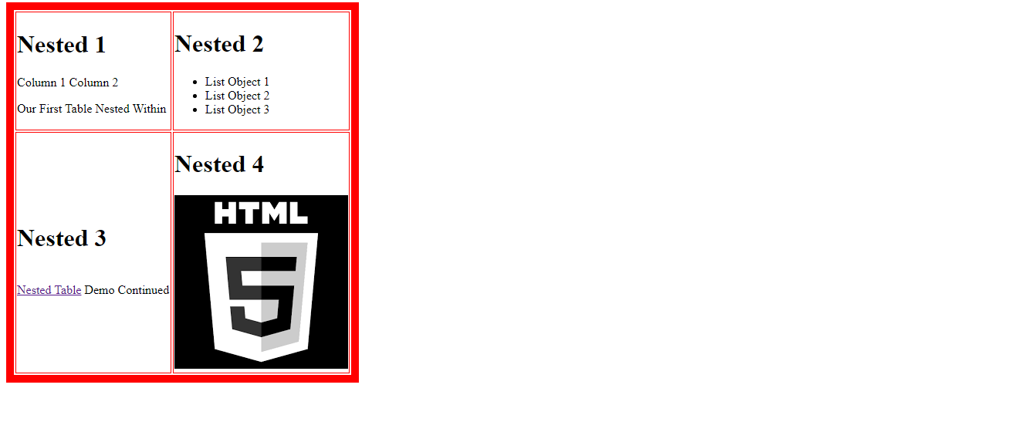

Question 2 :

<html>

<head>

<title>time table</title>

</head>

<body bgcolor="white">

<H1><FONT COLOR="black"><CENTER>online timetable slots</FONT></H1>

<table border="1" cellspacing="0" align="center">

<tr style="background-color: greenyellow" >

<td colspan="12" align="center"><font color="black">online time table<br>

</tr>

<tr style="background-color: yellow">

<td align="center" >Dept</td>

<td align="center" >CSE</td>

<td align="center" >semester</td>

<td align="center" >VII</td>

<td align="center" >class</td>

<td align="center" >B.tech</td>

<td align="center" >sec</td>

<td align="center" >d</td>

<td align="center" >class</td>

<td align="center" >advisor</td>

<td align="center" >email</td>

<td align="center">a@gmail.com</td>

</tr>

<tr >

<td align="center" >Time/Day</td>

<td align="center">slot1</td>

<td align="center">slot2</td>

<td align="center">slot3</td>

<td align="center">slot4</td>

<td align="center" style="background-color: lightblue"> break</td>

<td align="center">slot5</td>

<td align="center">slot6</td>

<td align="center">slot7</td>

<td align="center">slot8</td>

<td align="center">slot9</td>

<td align="center">slot 10</td>

</tr>

<tr>

<td align="center"></td>

<td align="center">9.00-10.00</td>

<td align="center">10.00-11.00</td>

<td align="center">11.00-12.00</td>

<td align="center">12.00-13.00</td>

<td style="background-color: lightblue" align="center">13.00-14.00</td>

<td align="center">14.00-15.00</td>

<td align="center">15.00-16.00</td>

<td align="center">16.00-17.00</td>

<td align="center">17.00-18.00</td>

<td align="center">18.00-19.00</td>

<td align="center">19.00-20.00</td>

</tr>

<tr>

<td align="center">MONDAY

<td align="center"><font color="black">SiCP<br>

<td align="center">---<br>

<td align="center">---<br>

<td align="center">---<br>

<td rowspan="6"align="center"><font color="blue"><br>L<br>U<br>N<br>C<br>H

<td colspan="2" align="center"><font color="black">Elective V Lab

15CSE431

Foundations of Data Science

Dr. Priyanka Kumar (Group 3)

Ms. V Gayathi (Group3)

Ms. S Shanmuga Priya (Group 3)

Dr. N M Dhanya (Group 2)

Ms. M Prathilothamai (Group2)

Ms. C Selvi (Group 2)

Mr. V Dayanand (Group 1)

Ms. R Sujee (Group1)

Ms. P Subathra (Group 1)

15CSE480

Internet of Things

Dr. V. Ananthanarayanan (Group 1)

Dr. P Bagavathi Siva Kumar (Group 1)

Ms. K Nalinadevi (Group1)

Mr. A Baskar (Group 3)

Dr. R Gowtham (Group 3)

Dr. K V Shriram (Group 3)

Mr. A K Sumesh (Group 2)

Dr. S Thangavelu (Group2)

Ms. G Radhika (Group 2)<br>

<td align="center">---<br>

<td align="center">---<br>

<td align="center"><font color="red">15CSE402 Structure and

Interpretation of

Computer Programs -

Discussion Hour

Dr. Raghesh Krishnan K<br>

</tr>

<tr>

<td align="center">TUESDAY

<td align="center"><font color="black">15CSE401

Machine Learning and Data Mining

Mr. Manu Madhavan<br>

<td align="center"><font color="black">Elective IV

15CSE338

Computational Intelligence

Ms. P subathra (Group 1)

Dr. C Arunkumar (Group 2)

15CSE343

Design Patterns

Dr. N Lalithamani

15CSE358

Natural Language Processing

Dr. M Senthilkumar(Group 1&2)

15CSE370

Wireless and Mobile

Communication

Dr. N Radhika (Group 1)

Dr. J Govindarajan (Group 2)<br>

<td align="center">---<br>

<td align="center">Elective V

15CSE431

Foundations of Data Science

Dr. Priyanka Kumar (Group 3)

Dr. N M Dhanya (Group 2)

Mr. V Dayanand (Group 1)

15CSE480

Internet of Things

Dr. V. Ananthanarayanan (Group

1)

Mr. A Baskar (Group 3)

Mr. A K Sumesh (Group 2)<br>

<td colspan="2" align="center">---<br>

<td align="center">---<br>

<td align="center">---<br>

<td align="center"><font color="red">15CSE401

Machine Learning and

Data Mining

Discussion Hour

Mr. Manu Madhavan<br>

</tr>

<tr>

<td align="center">WEDNESDAY

<td align="center"><font color="black">SiCP<br>

<td align="center">---<br>

<td align="center">---<br>

<td align="center">---<br>

<td colspan="2" align="center"><font color="black">15CSE481

Machine Learning

and Data Mining Lab

Mr. Manu Madhavan

Mr. B A Sabarish

Ms. R Archanaa<br>

<td align="center">---<br>

<td align="center">---<br>

<td align="center"><font color="red">Elective V Discussion

Hour

15CSE431 - FoDS

Dr. Priyanka Kumar(G1),

Dr. N M Dhanya(G2) and

Mr. V Dayanand(G3)

15CSE480 - IoT

Dr. V

Ananthanarayanan(G1),

Mr. A K Sumesh(G2)and

Mr. A Baskar(G3)<br>

</tr>

<tr>

<td align="center">THURSDAY

<td align="center"><font color="black">15CSE401

Machine Learning and Data Mining

Mr. Manu Madhavan<br>

<td align="center"><font color="black">Elective IV

15CSE338

Computational Intelligence

Ms. P subathra (Group 1)

Dr. C Arunkumar (Group 2)

15CSE343

Design Patterns

Dr. N Lalithamani

15CSE358

Natural Language Processing

Dr. M Senthilkumar(Group 1&2)

15CSE370

Wireless and Mobile

Communication

Dr. N Radhika (Group 1)

Dr. J Govindarajan (Group 2)<br>

<td align="center">---<br>

<td align="center">Elective V

15CSE431

Foundations of Data Science

Dr. Priyanka Kumar (Group 3)

Dr. N M Dhanya (Group 2)

Mr. V Dayanand (Group 1)

15CSE480

Internet of Things

Dr. V. Ananthanarayanan (Group

1)

Mr. A Baskar (Group 3)

Mr. A K Sumesh (Group 2)<br>

<td colspan="2" align="center">---<br>

<td align="center">---<br>

<td align="center">---<br>

<td align="center"><font color="red">Elective IV Discussion

Hour

15CSE338

Computational

Intelligence

Ms. P subathra (Group

1)

Dr. C Arunkumar (Group

2)

15CSE358

Natural Language

Processing(Group 1&2)

Dr. M Senthilkumar

15CSE370

Wireless and Mobile

Communication

Dr. N Radhika (Group 1)

Dr. J Govindarajan

(Group 2)<br>

</tr>

<tr>

<td align="center">FRIDAY

<td align="center"><font color="black">SiCP<br>

<td align="center">---<br>

<td align="center">---<br>

<td align="center">---<br>

<td colspan="2" align="center"><font color="black">Elective V Lab

15CSE431

Foundations of Data Science

Dr. Priyanka Kumar (Group 3)

Ms. V Gayathi (Group3)

Ms. S Shanmuga Priya (Group 3)

Dr. N M Dhanya (Group 2)

Ms. M Prathilothamai (Group2)

Ms. C Selvi (Group 2)

Mr. V Dayanand (Group 1)

Ms. R Sujee (Group1)

Ms. P Subathra (Group 1)

15CSE480

Internet of Things

Dr. V. Ananthanarayanan (Group 1)

Dr. P Bagavathi Siva Kumar (Group 1)

Ms. K Nalinadevi (Group1)

Mr. A Baskar (Group 3)

Dr. R Gowtham (Group 3)

Dr. K V Shriram (Group 3)

Mr. A K Sumesh (Group 2)

Dr. S Thangavelu (Group2)

Ms. G Radhika (Group 2)<br>

<td align="center">---<br>

<td align="center">---<br>

<td align="center"><font color="red">15CSE376

Net Centric

Programming

Discussion Hour

Dr. C Arunkumar<br>

</tr>

<tr>

<td align="center">SATURDAY

<td align="center"><font color="black">15CSE401

Machine Learning and Data Mining

Mr. Manu Madhavan<br>

<td align="center"><font color="black">Elective IV

15CSE338

Computational Intelligence

Ms. P subathra (Group 1)

Dr. C Arunkumar (Group 2)

15CSE343

Design Patterns

Dr. N Lalithamani

15CSE358

Natural Language Processing

Dr. M Senthilkumar(Group 1&2)

15CSE370

Wireless and Mobile

Communication

Dr. N Radhika (Group 1)

Dr. J Govindarajan (Group 2)<br>

<td align="center">---<br>

<td align="center">Elective V

15CSE431

Foundations of Data Science

Dr. Priyanka Kumar (Group 3)

Dr. N M Dhanya (Group 2)

Mr. V Dayanand (Group 1)

15CSE480

Internet of Things

Dr. V. Ananthanarayanan (Group

1)

Mr. A Baskar (Group 3)

Mr. A K Sumesh (Group 2)<br>

<td colspan="2" align="center">---<br>

<td align="center">---<br>

<td align="center">---<br>

<td align="center"><font color="red">Elective IV

Discussion Hour

15CSE343

Design Patterns

Dr. N Lalithamani<br>

</tr>

</body>

</html>

Output screenshot:

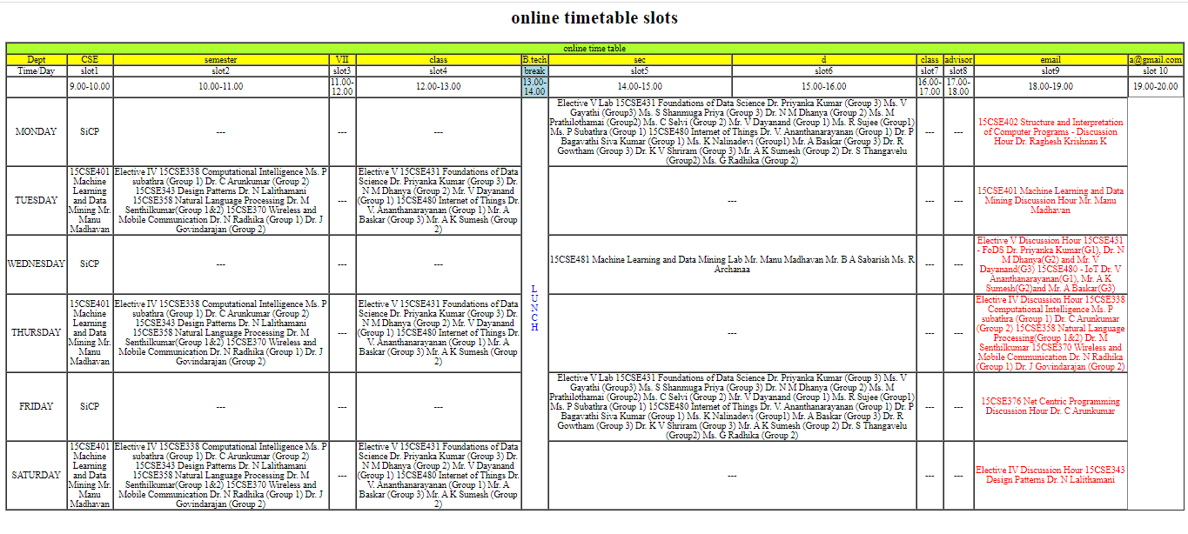

Question 3:

<html>

<head>

<title>image </title>

</head>

<img src="pic.jpg" usemap="#vicky">

<map name="vicky">

<area target="_blank" alt="cpu" title="cpu" href="https://en.wikipedia.org/wiki/Central_processing_unit" coords="108,6,174,127" shape="rect">

<area target="_blank" alt="monitor" title="monitor" href="https://en.wikipedia.org/wiki/Computer_monitor" coords="235,39,336,142" shape="rect">

<area target="_blank" alt="keyboard" title="keyboard" href="https://en.wikipedia.org/wiki/Computer_keyboard" coords="132,190,161,158,251,178,230,218" shape="poly">

<area target="_blank" alt="mouse" title="mouse" href="https://en.wikipedia.org/wiki/Computer_mouse" coords="274,179,301,222" shape="rect">

<area target="_blank" alt="printer" title="printer" href="printer.html" coords="371,198,474,247" shape="rect">

<area target="_blank" alt="speaker1" title="speaker1" href="https://en.wikipedia.org/wiki/Computer_speakers" coords="188,84,223,140" shape="rect">

<area target="_blank" alt="speaker2" title="speaker2" href="https://en.wikipedia.org/wiki/Computer_speakers" coords="350,86,387,143" shape="rect">

</map>

</html>

Output screenshot :

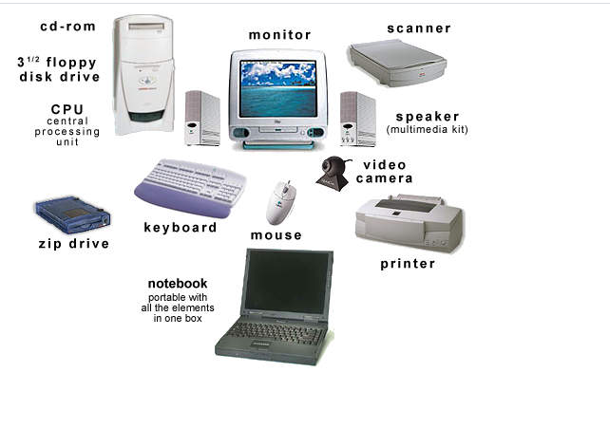

Question4:

Code :

<!DOCTYPE html>

<html>

<head>

<title>Frame tag</title>

</head>

<frameset rows="25%,25%,25%,25%">

<frame src="sub1.html" >

<frame src="sub2.html">

<frame src="sub3.html" >

<frame src="sub4.html">

</frameset>

</html>

Sub1 code :

<html>

<head>

<link rel="stylesheet" href="space.css">

</head>

<form>

<table>

<tr>

<td>

<input type="radio" id="id" name="id" value="id">

<label for="id">Id</label>

</td>

<td>

<input type="radio" id="pass" name="pass" value="pass">

<label for="pass">Passport</label>

</td>

<td>

<label for="num">Number</label>

<input type="text" id="num" name="num">

</td>

<td>

<label for="d">Passport exp date</label>

<input type="date" id="d" name="d">

</td>

<td> <label for="country">Country</label></td>

<td><select id="country" name="country">

<option value="India">India</option>

<option value="Korea">Korea</option>

<option value="japan">japan</option>

</select></td>

</tr>

</table>

</form>

</html>

Sub2 code:

<html>

<form>

<table>

<tr>

<td> <label for="title">Title</label>

<select id="title" name="title">

<option value="a">A</option>

<option value="b">B</option>

<option value="c">C</option>

</select>

</td>

<td>

<label for="fname">First Name</label>

<input type="text" id="fname" name="fname">

</td>

<td>

<label for="lname">Last Name</label>

<input type="text" id="lname" name="lname">

</td>

</tr>

<tr>

<td>

<label for="car">Demo car id</label>

<input type="text" id="car" name="car">

</td>

<td>

<label for="cname">Company card number</label>

<input type="text" id="cname" name="cname">

</td>

<td>

<label for="birthday">Birth date</label>

<input type="date" id="birthday" name="birthday">

</td>

</tr>

</table>

</form>

</html>

Sub3 code :

<html>

<form>

<table>

<tr>

<td> <label for="country">License Country</label>

<select id="country" name="country">

<option value="India">India</option>

<option value="Korea">Korea</option>

<option value="japan">japan</option>

</select></td>

<td>

<label for="idate">Issue date</label>

<input type="date" id="idate" name="idate">

</td>

<td>

<label for="iata">IATA</label>

<input type="text" id="iata" name="iata">

</td>

</tr>

<tr>

<td>

<label for="ln">Lisence number</label>

<input type="text" id="ln" name="ln">

</td>

<td>

<label for="edate">Expiry date</label>

<input type="date" id="edate" name="edate">

</td>

<td>

<label for="ph">Phone 1</label>

<input type="number" id="ph" name="ph">

</td>

</tr>

</table>

<table>

<tr>

<td>

<label for="ad">Address</label>

<input type="text" id="ad" name="ad">

</td>

<td>

<label for="pho">Phone 2</label>

<input type="number" id="pho" name="pho">

</td>

</tr>

<tr>

<td>

<input type="text" id="ad" name="ad">

</td>

<td>

<label for="p">Fax 1</label>

<input type="number" id="p" name="p">

</td>

</tr>

</table>

<table>

<tr>

<td>

<label for="c">City state</label>

<input type="text" id="c" name="c">

</td>

<td>

<label for="z">Zip</label>

<input type="number" id="z" name="z">

</td>

<td>

<label for="country">License Country</label>

<select id="country" name="country">

<option value="India">India</option>

<option value="Korea">Korea</option>

<option value="japan">japan</option>

</select>

</td>

<td>

<label for="s">SMS number</label>

<input type="number" id="s" name="s">

</td>

</tr>

</table>

</form>

</html>

Sub4 code :

<html>

<table>

<tr>

<td>

<label for="e">employer</label>

<input type="text" id="e" name="e">

<label for="co">customer sorce type</label>

<select id="co" name="co">

<option value="India">India</option>

<option value="Korea">Korea</option>

<option value="japan">japan</option>

</select>

</td>

<td>

<label for="Email">Email:</label>

<input type="text" id="Email" name="Email">

</td>

</tr>

<tr>

<td>

<label for="ad"> localAddress</label>

<input type="text" id="ad" name="ad">

</td>

<td>

<label for="pho">local Phone</label>

<input type="number" id="pho" name="pho">

</td>

</tr>

</table>

</html>

Output :

